Express Scripts, Inc.

Specialty Pharmacy Mobile Enterprise

Mobile Point of Care Application Design

Author: IBM

Owner: IBM

Customer: Express Scripts, Inc.

Document History

Document Location

This is a snapshot of an on-line document. Paper copies are valid only on the day they are printed. Refer to the author if you are in any doubt about the currency of this document.

Revision History

|  |  |  |  |
| --- | --- | --- | --- |
| Revision Number | Revision Date | Summary of Changes | Changes marked |
| 0.1 | 11/17/2014 | Initial version | (N) |
| 0.5 | 2/7/2015 | First submission to EA and IRM review board |  |
| 0.6 | 2/26/15 | Changes per the EA and IRM reviews |  |
| o.8 | 3/10/15 | Revise approvals section, add soa approval email |  |

Approvals

This document requires following approvals. Signed approval forms are filed in the Quality section of the PCB.

|  |  |
| --- | --- |
| Name | Title |
| Daniel Duncan | Enterprise Architecture |
| Rob Wilson | IRM |
| Mark Leiberg | IRM Security Architecture |
| Youri Hall | QA Lead |
| Dana Guetterman | Infrastructure BAT |
| Hari N | Technical Lead |
| Ken Johnson | Technical Lead |
| Lorrin Harvey | Requirements Lead |

The SOA Governance board has approved the design approval and the email is embedded below.



Contents

1. Introduction 4

1.1 Mobile Nurse Purpose 4

1.2 Mobile Nurse Scope 4

1.3 Assumptions 5

1.4 References 5

1.4.1 Customer Documents 5

1.4.2 Non-Customer Documents 5

2. Logical Design Overview 6

2.1 Operation Steps 6

3. Application Design 8

3.1 User Interface Design 8

3.1.1 Branding 8

3.1.2 Screen layout 11

3.1.3 Toolbars 12

3.1.4 Menu Behaviour 13

3.1.5 Interactive Components 14

3.2 Sequence Flow 17

3.2.1 Device Authentication 17

3.2.2 Get Schedules 17

3.2.3 Manual/Auto Upload Form 18

3.2.4 Nurse Logout 19

3.3 Data Design 20

3.3.1 Logical Data Model 20

3.3.2 Conceptual Data Model View(s) 20

3.3.4 Data Storage 22

4. Services 23

4.1 Mobile Aggregator Services 23

4.1.1 MPOC Auth Service 23

4.1.2 MPOC Aggregator Service 24

4.2 ESI Gateway Services 27

4.2.1 Mobile Session Verification Service 27

4.2.2 Mobile Nursing Gateway Service 28

5. Appendix 32

# Introduction

Express Scripts Incorporated (ESI) provides integrated, end-to-end support for pharmacy scripting. A key element of the ESI Specialty Pharmacy is to provide nursing care for terminally ill patients. Specialty pharmacy nurses currently use a Windows XP tablet based e-forms application called Mobile Point of Care (MPOC), a Nursing documentation system. It uses eForms on a mobile device and remote access. This allows nurses to complete documentation in a systematic way outside of office environments. The intent is to free up field nurses to concentrate on patient care and give them the ability to communicate all documentation remotely. This decreases the amount of Personal Health Information (PHI) mailed and faxed thereby lessening the potential HIPAA violations. This application has limitations with respect to usability and accessibility. The Mobile Nurse MPOC application is an iPad based application that is jointly developed by International Business Machines (IBM) and ESI to replace the MPOC tablet application.

## Mobile Nurse Purpose

The purpose of this document is to describe the design of the Express Scripts Incorporated (ESI) Specialty Pharmacy Mobile Nurse (ESI Mobile Nurse) application developed jointly by IBM and ESI. This application is developed to meet the like to like functionality of the ESI Mobile Point of Care (MPOC) application. This document provides a comprehensive design overview of the solution using a number of design patterns to depict different aspects of the application. As a result, the document communicates the macro design for the Mobile Nurse interacting with existing systems and providing mobility to nurses while performing their patient care duties.

## Mobile Nurse Scope

The scope of this document covers the ESI Mobile Nurse and the corresponding systems it interfaces with namely the ESI FileNet P8 Workplace and the RxHome. The Mobile Nurse is an iPad application that provides interfaces for nurses to document and submit care and therapy data in a like to like functionality to the MPOC application.

Figure 1 shows a high-level introduction to the ESI Mobile Nurse, and illustrates the system context. The ESI Mobile Nurse application interacts with multiple ESI enterprise backend components through the ESI Mobile Nurse Gateway and MPOC Aggregator.



Figure 1 ESI Mobile Nurse System Context – Target State

## Design Decisions

The purpose of this section is to list decisions, considerations and assumptions that are put in place for this design. New security standards and processes are being created for mobile framework. This project shall make all efforts to comply with these standards. When the compliance cannot be met in a timely manner, they shall be planned for the subsequent releases

**Technical**

1. Existing FileNet P8 APIs are used to store the nurses’ notes to ESI backend systems.
2. Existing SGIATMS web services are used to extract nurse visit session data from ESI backend systems.
3. All interactions between IBM MobileFirst, RxHome and SGIATMS are performed through the Mobile Nursing Gateway.
4. Management of iPad devices and applications shall be done through the enterprise Mobile Device Management/ Mobile Application Management (MDM/MAM) solutions, currently Good for Enterprise (GFE).

**Security**

1. Secure communication protocols (SSH/HTTPS) shall be used for entry points such as Mobile Nursing Gateway.
2. Mobile Nursing Gateway services shall be Simple Object Access Protocol (SOAP) services with XML as payload.
3. Communication protocols from behind the Mobile Nursing Gateway shall not be changed. Necessary changes as per security requirements shall be addressed in the future releases.
4. GFE handles device and user authentications and provides Good authentication tokens to be used for further communications.
5. The Mobile Nurse shall use the Good authentication tokens for all communications.

## References

* Arch Design Options Alignment

<http://sharepoint/sites/FEPSProjects/Projects/118786%20-%20MPoC%202.0/03%20-%20Design/MPOC%20Threat%20Model%20-%20MJL.vsd>

* Contextual/Conceptual Arch and Data Flows

<http://sharepoint/sites/FEPSProjects/Projects/118786%20-%20MPoC%202.0/03%20-%20Design/MPOC%20Data%20Flows%20(2).vsd>

* Internal Service Arch Design including transitional states

<http://sharepoint/sites/FEPSProjects/Projects/118786%20-%20MPoC%202.0/03%20-%20Design/MPOC%20Internal%20Services.vsd>

* Mobile Nurse Gateway Service Web Service Descriptive Language (WSDL)

MobileNurseGateway.wsdl

* Mobile Auth Service Web Service Descriptive Language (WSDL)

MobileSecurityGateway.wsdl

# Logical Design Overview

Documenting the design begins with development of the logical overview. This overview illustrates the entire system, represented as a black box, and how it interacts with internal and external entities (systems and end users). It is used to clarify, confirm, and document the environment in which the system operates. The interaction with the external systems, their interfaces, and the information and control flows will help in the development of technical artifacts that fully document the architecture. The logical overview diagram is shown in the Figure 2.



Figure 2 Logical Overview – Target State

## Operation Steps

Mobile Nurse contains four main operations namely, Device Login, User Login/Logout, Get Appointments and Upload Note. The sequence of steps for these operations is shown in this diagram.

Device and user logins are handled by the Good Dynamics infrastructure. Once both logins are successful, an authentication token is made available on the iPad. This token shall be used in communication with the ESI infrastructure in order to get appointments and upload notes.



Figure 3 Operations from Nurse iPad Walkthrough – Target State

For a visual summary of the walkthrough, please refer to the color trace in the associated figure.

Note that all incoming and outgoing requests to the internet are mediated by the firewalls. Firewall interactions are assumed and will be omitted in this walkthrough, for brevity and clarity.

1. The device management is handled through Good MDM/MAM
2. The nurse performs user authentication against Good Control/Proxy infrastructure through Good Network Operation Center (NOC)
3. The Good Control server authenticates user against the enterprise directory. Once authentication is successful, the authentication token (auth token) is sent back to the iPad node through the NOC
4. The nurse performs get appointment list or upload note operations. The iPad node sends request to Good Control server via the Good NOC along with the authentication token.
5. The Good Proxy server forwards the request to MPOC Aggregator.
6. The MPOC Aggregator validates the Good auth token against the Good Control infrastructure through the Mobile Security Gateway
7. The MPOC Aggregator sends the request to Mobile Nurse Gateway (Red).
8. The Mobile Nurse Gateway validates the Good auth token against the Good Control infrastructure through the Mobile Security Gateway
9. The Mobile Nurse Gateway reaches to the enterprise backend systems (FileNet, SGIATMS) to perform the operations.
10. The Mobile Nurse Gateway returns the response (either the appointment list or the status of upload) to the Aggregator.
11. The MPOC Aggregator returns the response to the iPad through Good Control/Proxy and Good NOC.

# Application Design

This section contains the design for the Mobile Nurse application. Mobile Nurse application is a part of the Mobile Point of Care (MPOC) system that provides user interfaces to allow nurses to collect therapy and patient care data during their visits. The mobile nurse application connects to ESI infrastructure through a set of web service calls to obtain and submit patient visitation and therapy related data.

This section consists of sub sections that present user interfaces (UI), data design and protocols to communicate with the enterprise infrastructure. Section 4.1 presents the UI design, the following section presents the data design and section 4.3 presents the protocols used.

## User Interface Design

This section presents a high level design of the user interfaces for the Mobile Nurse application. Mobile Nurse is essentially a form based application that follows the same flow logic as the current version of the Mobile Point of Care (MPOC) application.

### Branding

The brand elements for the designs/UI will be modeled after the Accredo brand guidelines, found at <https://es-eod.thebrandauthority.com/app/do/User/Home>.

**Logo Color Specifications**

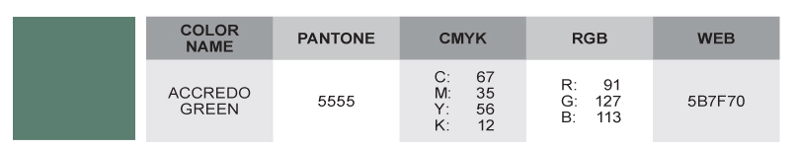

**Primary Palette – Light**

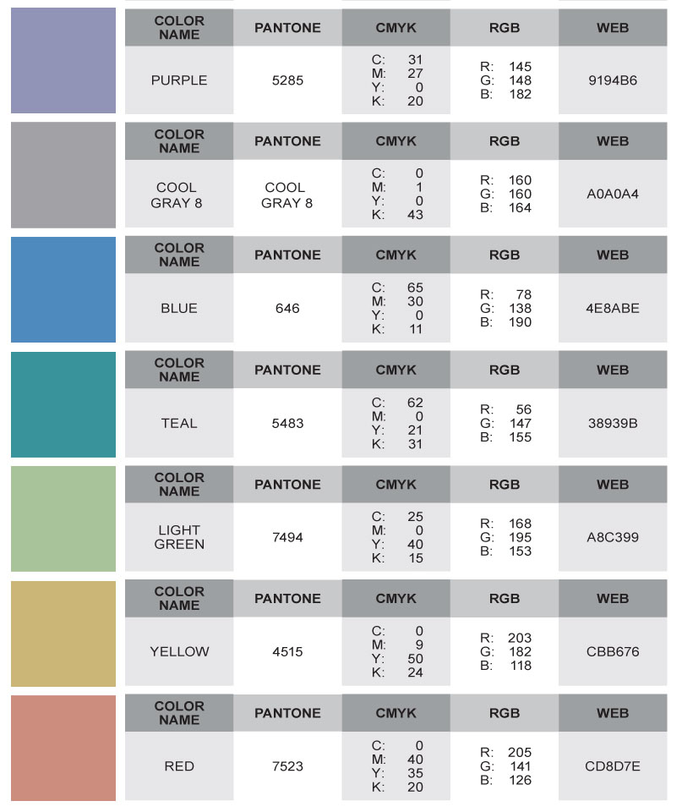

**Secondary Palette – Dark**

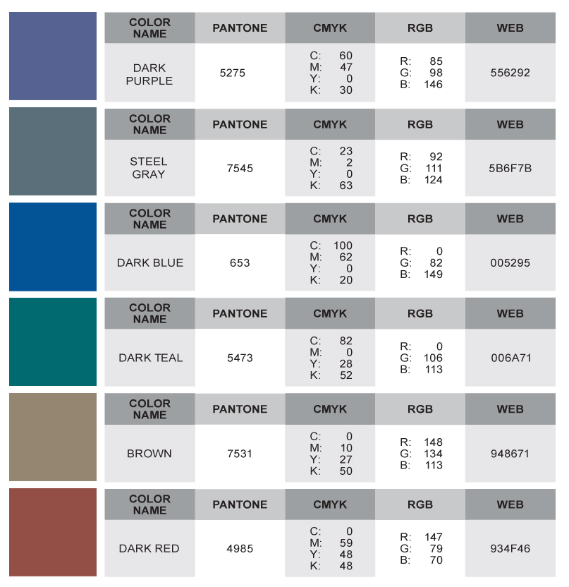

**Font Specifications**

The iOS System Font should be used.

### Screen layout

One iPad design/UI footprint is supported: Tablet horizontal (2048x1536). The screen is locked in landscape mode, even when the end user turns the iPad to portrait orientation. Two types of layouts are used by the nCare application design: Centered and Three-Column.

**Centered Layout**

The Log In and Patient List screens are examples where the interactive elements are centered.

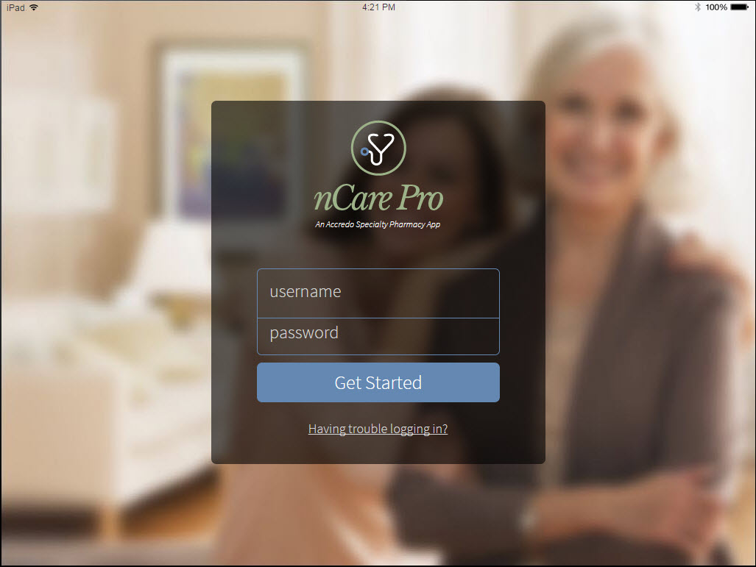

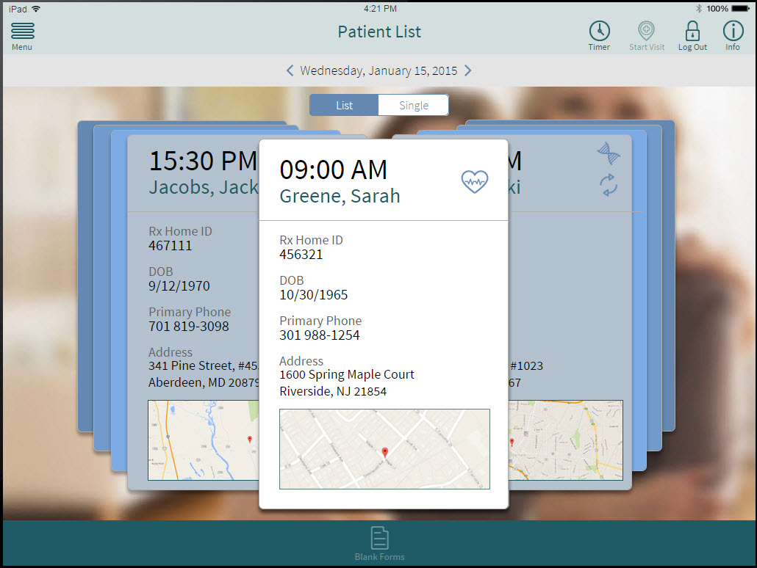

**Three-Column Layout**

Form data-entry screens use a 3-column layout in which rows of data entry fields span three columns. Design elements, such as toggle bars or section headings, may span the full three column space.

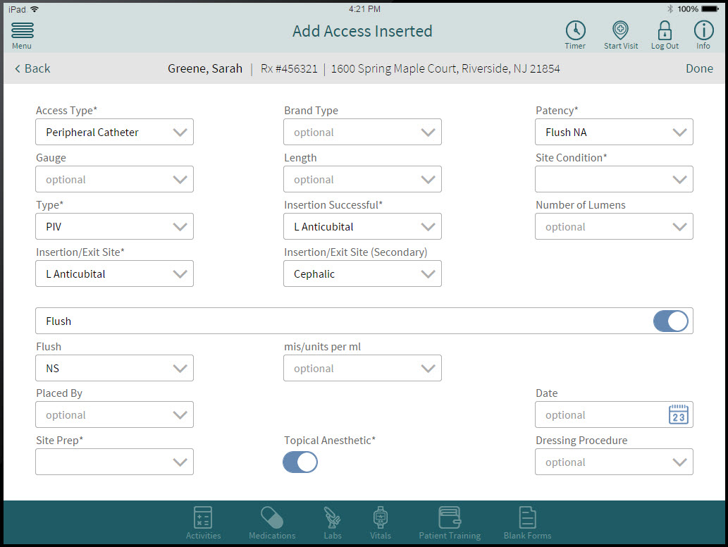

### Toolbars

The application presents two persistent toolbar areas, at the top and at the bottom of the application screen. This enables users to quickly identify and navigate to key tools and frequently used sections of the application.

**Top Toolbar**

The top toolbar presents the key tools and navigation Nurses will need ready access to throughout the application. Additionally, when appropriate, a persistent banner identifies the specific patient for whom they are recording data.

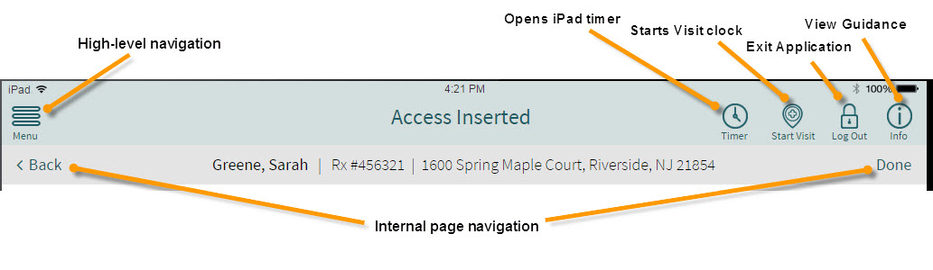

**Bottom Toolbar**

The bottom toolbar enables one-click access to screens nurses may frequently view during a patient visit.

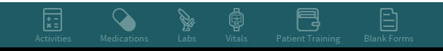

### Menu Behaviour

**High Level Navigation – Open**

When the user taps the Menu icon in the upper left corner, the navigation bar will appear as sliding over the primary screen layer. Only sections of the form driven by business logic should appear in the navigation list.

Elements on the primary screen layer are no longer active, but if the user taps in this primary screen layer area, the navigation menu will slide/exit to the left. When the user selects from the navigation, the application will refresh to the new view, or if the navigation element is indicated with a >, then a submenu will appear.

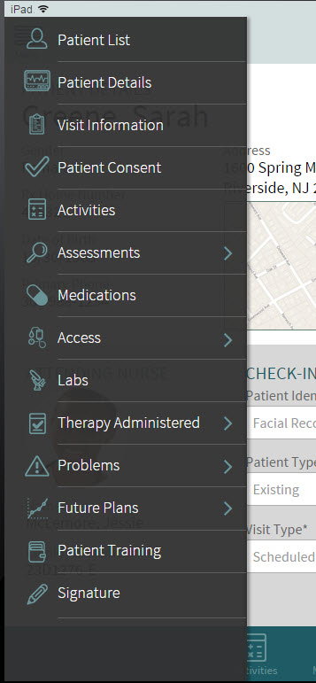

**High Level Navigation – Open with Subnavigation Expanded**

When the user taps a navigation element that is indicated with a >, then a submenu will appear. Each element in the submenu will have a ON/OFF toggle switch. Generally, the switch will default to OFF, with some exceptions based on business logic. When the user taps a navigation element, the switch will change to/remain ON, and the application will present the related view as the menu exits/slides to the left.

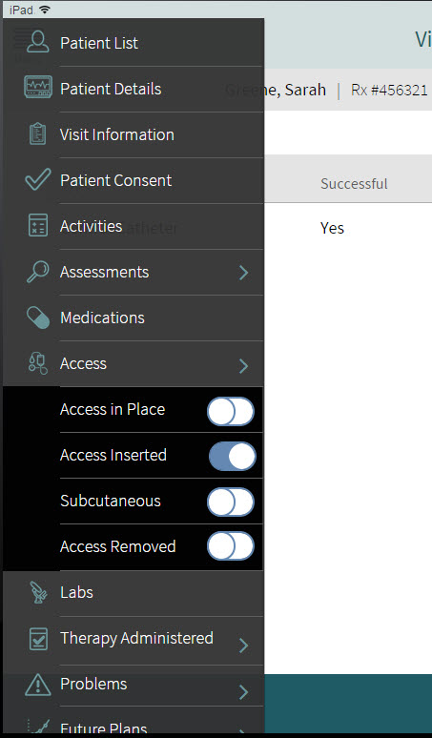

### Interactive Components

The layout and interactions use Apple’s Human Interface Guidelines, a standard model for state of the art mobile apps: <https://developer.apple.com/library/ios/documentation/userexperience/conceptual/MobileHIG/index.html>

Interactive controls commonly used in the application are described in the following sections.

**Form fields**

* Required fields are indicated by an * (asterisk), optional fields are indicated by the hint text ‘optional’ within the field.
* Form field types: Boolean switch, text field, date field, time field, single selection drop-down, and multiple selection drop-down.

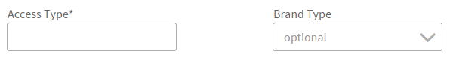 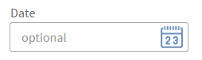

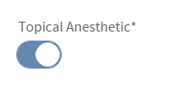

* Both single and multiple selections drop-downs can include capability for an “Other” choice which dynamically presents a text field.

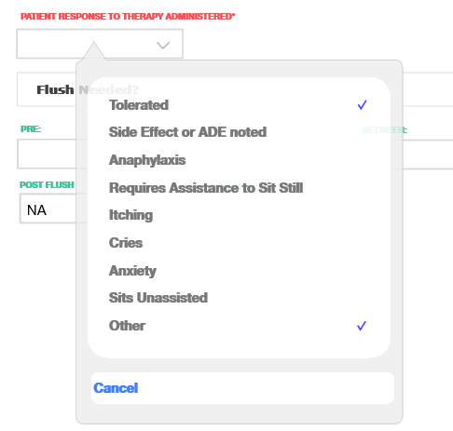 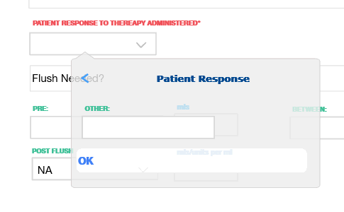

**Table data entry popover**

* When minimal form fields are needed to populate a table, a popover view is recommended.

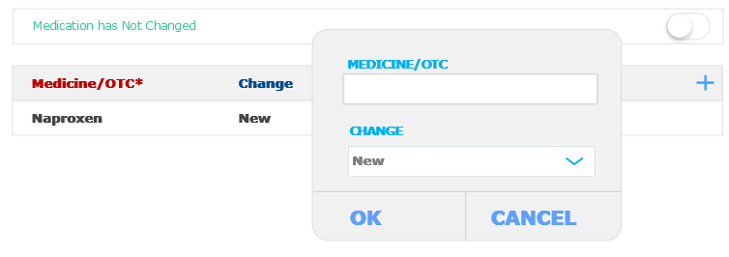

**Table data entry – secondary screen**

* When many form fields (generally greater than 7) are needed to populate a table, a secondary screen view is recommended.

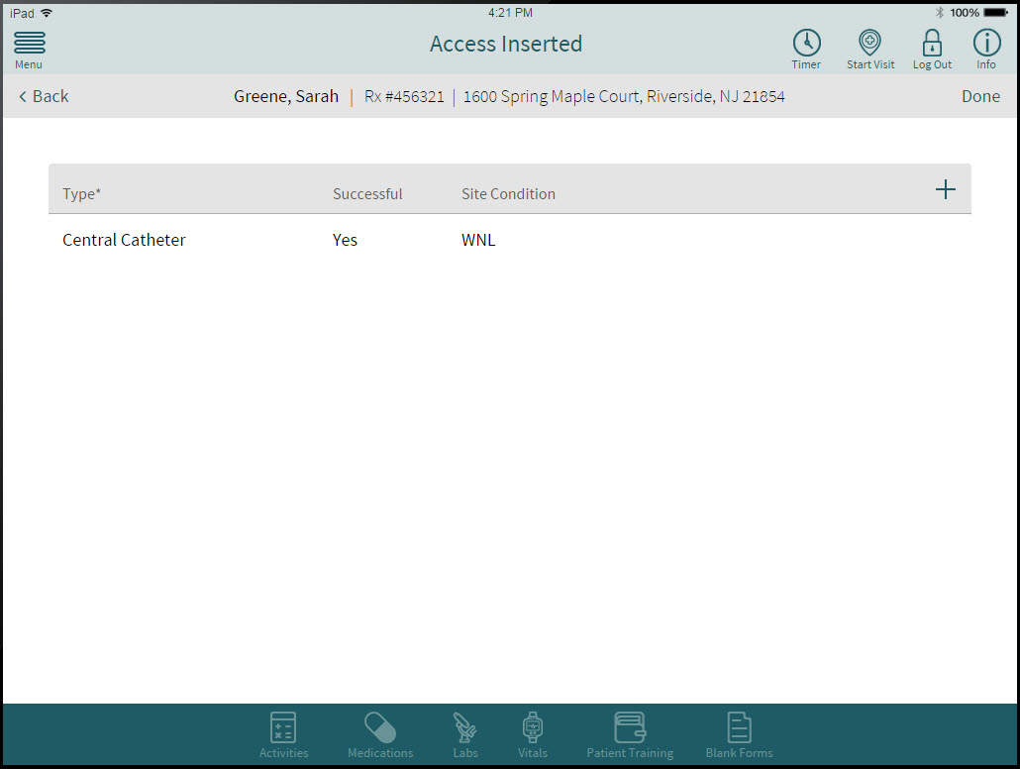



## Sequence Flow

This section contains the flow of sequences during the operation of the Mobile Nurse application. The Mobile Nurse application supports four main operations for nurses namely, Device Login, User Login/Logout, Get Appointments and Upload Note. The sequence of steps for each of these operations are shown in the following sections.

### Device Authentication

This section contains the flow for iPad device authentication. This flow has pre-conditions that the iPad is provisioned, managed and secured as per the ESI enterprise standards and MDM solution.



Figure 4 Device Authentication Sequence

### User Login

This flow shows the sequences for the nurse login on the iPad to the ESI infrastructure by using the Good container on the device. This login sequence authenticates the nurse against the enterprise directory through the GFE solution and establishes a secure connection over the internet into the ESI infrastructure. This secure connection shall be used for other tools and applications as well as the Mobile Nurse.

#### Pre-Conditions:

1. User performed device authentication by entering the device pin according to the ESI MDM configuration policy
2. Good Container is loaded and available for the user.



Figure 5 User Authentication Sequence

### Get Appointments

This flow contains the sequences for obtaining logged in nurse’s schedules from the ESI backend system. This flow assumes that the following preconditions are met.

#### Pre-Conditions:

1. User performed device authentication by entering the device pin according to the ESI MDM configuration policy.
2. Nurse perform Good Dynamics (GD) Runtime container authentication if not already performed.
3. Mobile Nurse application activated by tapping on the Mobile Nurse icon.

# 

### Manual Upload Form

This flow contains the sequence for manual uploading nurse’s notes to the ESI backend system. Manual upload occurs after the nurse signs the page and submits the form while the device’s 4G/Wi-Fi connectivity is active and is able to connect to the IBM Mobile Aggregator.

. If the connectivity to the ESI infrastructure is not available, the notes data shall be saved in the local storage for a future submission.

#### Pre-Conditions:

1. User performed device authentication by entering the device pin according to the ESI MDM configuration policy
2. User perform Good Dynamics (GD) Runtime container authentication
3. User has successfully completed filling out the nurse note, including the Signature page and selected to submit



Figure 6 Nurse Note Upload - Manual

.

### Auto Upload Form

This flow contains the sequence for uploading nurse’s notes to the ESI backend system automatically without user intervention with the Mobile Nurse application.

Auto upload occurs if there are un-submitted but completed nurse note in the system, and there occurs an event where the device’s 4G/Wi-Fi connectivity is active. Additionally, the Good authentication token should also be active.

This flow assumes that the following preconditions are met.

#### Pre-Conditions:

1. User performed device authentication by entering the device pin according to the ESI MDM configuration policy
2. User perform Good Dynamics (GD) Runtime container authentication
3. User has successfully completed filling out the nurse note.



Figure 7 Upload Note - Auto

### User Logout

This section shows the sequence for the manual user logout. The action is initiated by the user and the logout is handled by the Good Infrastructure.

Auto logout is handled by the expiration of the Good authentication token. ESI MDM configuration policy allows for configurable session and device timeouts.



Figure 8 User Logout

### User Offline Authentication

User offline authentication sequence is displayed in this section. Offline authentication happens when the user attempts to access the Mobile Nurse application when the device 4G/Wi-Fi capabilities are disabled.

#### Pre-condition(s):

1. User performed device authentication by entering the device pin according to the ESI MDM configuration policy.
2. User had successfully logged onto ESI backend using Good container successfully.



Figure 9: User Offline Access

### User Authentication Failure

This section shows the sequence of operations on the device when the user authentication fails due to invalid or expired Good authentication token. ESI MDM configuration policy allows for configurable session and device timeouts. This is enforced by the Good Infrastructure.

#### Pre-condition(s):

1. User performed device authentication by entering the device pin according to the ESI MDM configuration policy.
2. User had successfully logged onto ESI backend using Good container successfully.
3. Mobile Nurse application is activated by tapping on the Mobile Nurse icon
4. User has allowed the Good authentication token to expire.



Figure 10 Upload Note - Invalid Token

## Data Design

This section presents the data design for the Mobile Nurse application. The first section presents the logical data model, followed by the conceptual data model in the preceding section and the Core data model in the section 4.1.3

### Logical Data Model

The Logical Data Model is a network of entities and relationships. This network is a persistent record made by the system representing business information structures and rules. The following diagram shows the such relationships. Because of the number of entities that are required and their singular relationship to Visit Information entity, a single diagram showing the complete relationship will be illegible and hence the following diagram shows key entities such as Patient, Nurse and Appointment Details and Visit Information. The following table lists all the entities and the relationships.

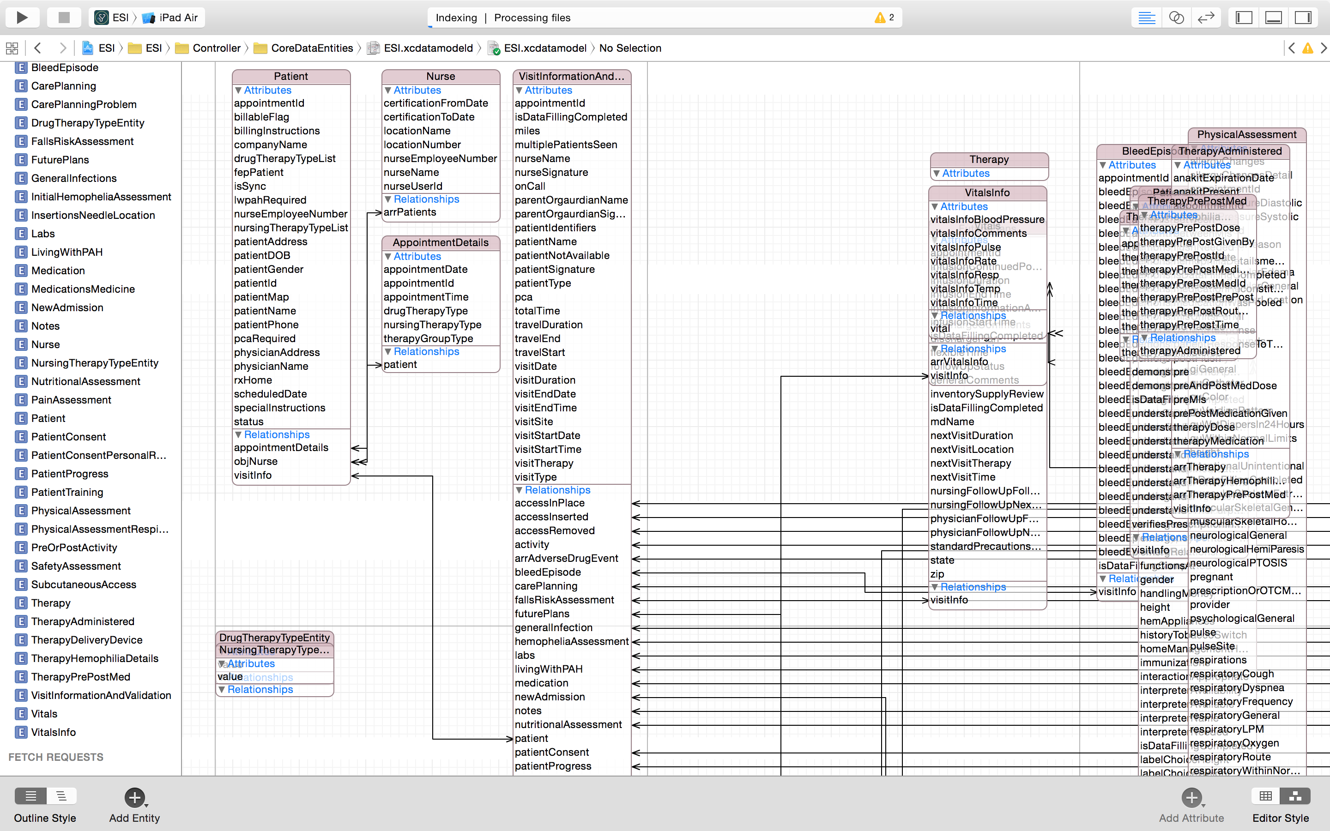

Figure 11 Logical Data Model

Core Data Model

Core Data is an object graph and persistence framework provided by Apple in the Mac OS X and iOS operating systems. This section contains the Core data entities used by the Mobile Nurse application.

The table below shows the Core Data entities.

|  |  |
| --- | --- |
| **Entity** | **Description** |
| Nurse | Contains basic reference to Nurse |
| Patient | Contains basic reference to the patient |
| AccessInPlace | Contains Access In Place data elements |
| AccessInPlaceClottingAgents | Contains Access In Place ClottingAgents data elements |
| AccessInserted | Contains Access Inserted data elements |
| AccessRemoved | Contains Access Removed data elements |
| Activity | Contains Activity data elements |
| Adverse Drug Event | Contains Adverse Drug Event data elements |
| Appointment Details | Contains Appointment Details data elements |
| Bleed Episode | Contains Bleed Episode data elements |
| Care Planning | Contains Care Planning data elements |
| Care Planning Problem | Contains Drug Therapy Type Entity data elements |
| Drug Therapy Type Entity | Contains Drug Therapy Type Entity data elements |
| Fall Risk Assessment | Contains Fall Risk Assessment data elements |
| Future Plans | Contains Future Plans data elements |
| General Infections | Contains General Infections data elements |
| Initial Hemophilia Assessment | Contains Initial Hemophilia Assessment data elements |
| Insertions Needle Location | Contains Insertions Needle Location data elements |
| Labs | Contains Labs data elements |
| Living With PAH | Contains Living With PAH data elements |
| Medications | Contains Medications data elements |
| Medications Medicine | Contains New Admission data elements |
| New Admission | Contains New Admission data elements |
| Notes | Contains Notes data elements |
| Nursing Therapy Type Entity | Contains Nursing Therapy Type Entity data elements |
| Nutritional Assessment | Contains Nutritional Assessment data elements |
| Pain Assessment | Contains Pain Assessment data elements |
| Patient Progress | Contains Patient Progress data elements |
| Patient Consent | Contains Patient Consent data elements |
| Patient Consent Personal Representative | Contains Patient Consent Personal Representative data elements |
| Patient Progress | Contains Activity data elements |
| Patient Training | Contains Patient Training data elements |
| Physical Assessment | Contains Physical Assessment data elements |
| Physical Assessment Respiratory | Contains Physical Assessment Respiratory data elements |
| Pre Or Post Activity | Contains Pre Or Post Activity data elements |
| Safety Assessment | Contains Safety Assessment data elements |
| Subcutaneous Access | Contains Subcutaneous Access data elements |
| Therapy | Contains Therapy data elements |
| Therapy Administered | Contains Therapy Delivery Device data elements |
| Therapy Delivery Device | Contains Therapy Delivery Device data elements |
| Therapy Hemophilia Details | Contains Therapy Hemophilia Details data elements |
| Therapy Pre Post Med | Contains Therapy Pre Post Med data elements |
| Visit Information and Validation | Contains Visit Information and Validation data elements |
| Vitals | Contains Vitals data elements |
| Vitals Info | Contains Vitals Info data elements |

### Data Storage

This section presents the temporary data storage handled by the Mobile Nurse application.

The Mobile Nurse stores the application data in the iOS on device storage through iOS Core Data in the binary format. The Good Container SDK provides additional encryption to the data that is being stored. The Mobile Nurse application uses Good Container SDK in order to achieve containerization for data storage as well as data transmission. The following diagram shows the relationships and usage of various components that are used in the data storage.



Figure 12 Mobile Nurse Data Storage

The Mobile Nurse is not the storage of record for nurse notes.

# Services

This section contains the design for the services that are developed for the ESI Mobile Nurse application. Section 4.1 shows the high level design for MPOC Aggregator Services and section 4.2 shows a similar design for the Mobile Nurse Gateway services.

The following diagram shows the layout of the different services and their interactions.



Figure 13 Mobile Nurse Service - High Level - Target State

## MPOC Aggregator Services

This section provides the high-level design for the MPOC Aggregator Services. These service provide interfaces between the Mobile Nurse Application and ESI Mobile Gateway to exchange nurse information.

The MPOC Aggregator Services are intermediary web services that provide pass through access to ESI Gateway Services. The receiving interfaces of these services are designed as Representational State Transfer (REST) services with Javascript Object Notation (JSON) as payload, and implemented on IBM MobileFirst platform. These services communicate with ESI Gateway using SOAP web service clients using XML as message payload over HTTPS. In addition to being pass through, these services perform data transformation from/to JSON to XML.

### MPOC Auth Service

This section provides the high-level APIs between the Mobile Nurse application and the MPOC Auth Service.

The MPOC Auth Service implement ValidateAuthToken interface using Worklight adapter. The following diagram shows the ValidateAuthToken interface for the MPOC Auth Service. The input and the output data types are also shown.



Figure 14 MPOC Auth Service – High Level

The following table shows the service operations, their data types and URLs.

|  |  |  |  |
| --- | --- | --- | --- |
| API Name | | ValidateAuthToken operation in MPOC Auth Service | |
| Description | | This operation validates the supplied token by forwarding the token to the ESI Mobile Security Gateway. | |
| Method Name | | ValidateAuthToken |
| Rest URL & HTTP Method | | / ValidateAuthToken  POST |
| Transport Security | | HTTPS |
| Encryption | | AES256 |
| Logging | | WL Logger (Worklight Server logging ) |
| Input Data | | Userid (encrypted)  AuthenticationToken (encrypted) |
| Output Data Success | | Nurse Data {"Nurse":{"NurseId":"<nurseId>", "NurseLastName":<lastname>, "NurseFirstName":<nurseName>}, “AuthTokenStatus”:valid }  HTTP Response Code: 200  HTTP Session Id  Authentication Token Token |
| Service Provider | | IBM | |

### MPOC Aggregator Service

The MPOC Aggregator Service implements GetApptList and UploadNote operations. The following diagram and the table show the services, the input and output types for the MPOC Scheduling Service.



Figure 15 MPOC Aggregator

The following table shows the service operations, their data types and URLs

|  |  |  |  |
| --- | --- | --- | --- |
| API Name | | MPOC Aggregator Service | |
| Description | | This service provides available appointments for the given nurse specified by the nurse identifier within the specified days.. | |
| Method Name | | Get Appointment List for Nurse |
| Rest URL & Method | | /GetApptList  POST |
| Transport Security | | HTTPS |
| Encryption | | AES256 |
| Logging | | WL Logger (Worklight Server logging ) |
| Input Data (HTTP Header) | | AuthenticationToken (encrypted) |
| Input Data (HTTP Request) | | NurseId  daysForward (Number of days forward to search)  daysPast (Number of days in the past to search) |
| Output Data | | List of Schedules as shown below  {"apptPatientsResponse": {"nurseId": 75323,  "nurseName": "kjohnson",  "nurseServiceBranch": 260,  "pahTherapies": "ADMP",  "apptPatientInformation": [{  "patientId": 2732263,  "firstName": "KEN",  "lastName": "PATIENT",  "sex": "Male",  "city": "TAMPA",  "state": "FL",  "zip": "33613",  "birthDate": "1986-05-01",  "physicianFirstName": "Doctor",  "physicianLastName": "DOMINGUEZ",  "physicianStreet": "3645 MADACA LANE",  "physicianCity": "TAMPA",  "physicianState": "FL",  "physicianZip": "33618",  "billableFlag": "NON-BILL",  "billingInstructions": "MEDI/MEDI",  "specialInstructions": "",  "drugTherapyType": "GGIV",  "drugTherapyType": "IVGP",  "nursingTherapyType": "PRNV",  "nursingTherapyType": "",  "pcaRequired": "false",  "lwpahRequired": "true",  "companyName": "ACCREDO",  "fepPatient": "false",  "appointment":[ {  "appointmentId": 271893,  "appointmentDate": "01/08/2015",  "appointmentTime": "08: 00"  }]  }  } |
| Method Name | | Upload Notes Data |
| Rest URL & HTTP Method | | /uploadNote  POST |
| Input Data (HTTP Header) | | AuthenticationToken (encrypted) |
|  | |  |
| Input Data | | Note data in JSON format  Sample:  "AdverseDrugEvent": [{  "adeType": "222",  "ageRange": "222",  "bmiRange": "222",  "classification": "222",  "comments": "222",  "dateofADE": "222",  "drContacted": "222",  "employmentStatus": "222",  "medicatlAttention": "222",  "missedwork": "222",  "patientId": "222",  "personReporting": "222",  "primarySideEffect": "222",  "primarySideEffectIntensity": "222",  "product": "222",  "secondarySideEffect": "222",  "therapyInterrupted": "222",  "timeMissed": "222",  "whenPrimarySideEffect": "222",  "whenSecondarySideEffect": "222",  "whereMedicalAttentionSought": "223"  }] |
| Output Data | | Success or Failure in JSON format  {“Status”:Success/Failure, “FailureCode”:0} |
| Service Provider | | IBM | |

## ESI Gateway Services

This section describes the high-level service design for the ESI Gateway services and interfaces between the Mobile Aggregator System and the ESI backend such as RxHome and FileNet P8 systems.

The ESI Gateway Services are enterprise web services that provide entry and exit points into ESI middleware. These are designed as Simple Object Access Protocol (SOAP) services with XML as payload and implemented on ESI Mule framework. These web services are developed in accordance with ESI standards, patterns and frameworks including the ESI SOA governance processes.

### Mobile Security Gateway Service

The Mobile Security Gateway Service provides gateway access for the enterprise mobile security functions. This gateway is designed and implemented on the ESI Mule framework according to the ESI enterprise standards and is dependent on the enterprise mobile security framework (a.ka Good Dynamics).

One operation the Mobile Security Gateway Service provides is AuthTokenValidate, which offers callers to verify and validate common (Good) authentication token. The implementation of this operation relies on the GD infrastructure and services. The following diagram shows the high level view of this service.



Figure 16 Mobile Security Service - ESI - Target State

The callers of these service provide an authentication token to be validated. The token authentication is passed on to the Good Control/Proxy servers which in turn depends on ESI enterprise directory servers for user validation. The response contain the status of the validation and the token, which is sent back to the caller.

The following table shows the service operations, their data types and URLs

|  |  |
| --- | --- |
| API Name | Validate Authentication Token |
| Description | Provides programmable interface to authenticate given user authentication token which in turn relies on Good Control/Proxy servers to validate the token. |
| SOAP Operation | /AuthTokenValidate |
| HTTPS Method | POST |
| Input Data | Userid (encrypted)  Authentication Token (encrypted) |
| Result Data | Nurse Id, Session Id – if login successful  error message – if login unsuccessful |
| Transport Security | HTTPS for inbound interface |
| Encryption | AES256 |
| Logging | Wiley Loggin Framework for monitoring.  Log4J for audit access logging, Log4J synchronized with LogLogic |
| Service Provider | ESI |

#### Web Service Descriptive Language (WSDL)

This section presents the Web Service Descriptive Language (WSDL) for the Mobile Security Gateway. The diagram below shows the high level view of the WSDL, and the table following contains the complete WSDL. The file is also referenced in the section 1.4

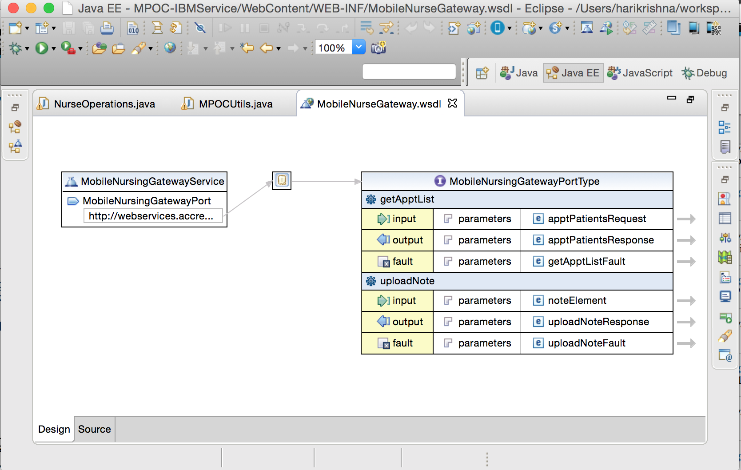

|  |
| --- |
| <?xml version="1.0" encoding="UTF-8"?><wsdl:definitions name="MobileSecurityGateway" targetNamespace="http://www.example.org/MobileSecurityGateway/" xmlns:wsdl="http://schemas.xmlsoap.org/wsdl/" xmlns:tns="http://www.example.org/MobileSecurityGateway/" xmlns:xsd="http://www.w3.org/2001/XMLSchema" xmlns:soap="http://schemas.xmlsoap.org/wsdl/soap/">  <wsdl:types><xsd:schema xmlns:xsd="http://www.w3.org/2001/XMLSchema" targetNamespace="http://www.example.org/MobileSecurityGateway/">  <xsd:element name="AuthTokenRequest">  <xsd:complexType>  <xsd:sequence>  <xsd:element name="goodToken" type="xsd:string"></xsd:element>  </xsd:sequence>  </xsd:complexType>  </xsd:element>  <xsd:element name="AuthTokenValidateResponse">  <xsd:complexType>  <xsd:sequence>  <xsd:element name="out" type="xsd:string"></xsd:element>  </xsd:sequence>  </xsd:complexType>  </xsd:element><xsd:element name="AuthTokenValidate Fault" type="xsd:string"></xsd:element>  <xsd:element name="InvalidRequest"  type="tns:InvalidRequestFaultType">  </xsd:element>  <xsd:complexType name="InvalidRequestFaultType">  <xsd:sequence>  <xsd:element name="faultId" type="xsd:int"></xsd:element>  <xsd:element name="faultString" type="xsd:string"></xsd:element>  <xsd:element name="userId" type="xsd:int"></xsd:element>  <xsd:element name="userName" type="xsd:string"></xsd:element>  <xsd:element name="authToken" type="xsd:string"></xsd:element>  <xsd:element name="faultDescription" type="xsd:string"></xsd:element>  </xsd:sequence>  </xsd:complexType>  <xsd:element name="AuthTokenResponse"  type="tns:AuthTokenResponseType">  </xsd:element>  <xsd:complexType name="AuthTokenResponseType">  <xsd:sequence>  <xsd:element name="authToken" type="xsd:string"></xsd:element>  </xsd:sequence>  </xsd:complexType>  </xsd:schema></wsdl:types>  <wsdl:message name="AuthTokenValidate Request">  <wsdl:part name="parameter" element="tns:AuthTokenRequest"></wsdl:part>  </wsdl:message>  <wsdl:message name="AuthTokenValidate Response">  <wsdl:part name="parameter" element="tns:AuthTokenResponse"></wsdl:part>  </wsdl:message>  <wsdl:message name="AuthTokenValidate Fault">  <wsdl:part name="fault" element="tns:InvalidRequest"></wsdl:part>  </wsdl:message>  <wsdl:portType name="MobileSecurityGatewayPortType">  <wsdl:operation name="AuthTokenValidate ">  <wsdl:input message="tns:AuthTokenValidate Request"></wsdl:input>  <wsdl:output message="tns:AuthTokenValidate Response"></wsdl:output>  <wsdl:fault name="fault" message="tns:AuthTokenValidate Fault"></wsdl:fault>  </wsdl:operation>  </wsdl:portType>  <wsdl:binding name="MobileSecurityGatewayBinding" type="tns:MobileSecurityGatewayPortType"></wsdl:binding>  <wsdl:service name="MobileSecurityGateway">  <wsdl:port name="NewPort" binding="tns:MobileSecurityGatewayBinding">  <soap:address location="http://webservices.accredo.acdo/gateway/MobileSecurityGateway" />  </wsdl:port>  </wsdl:service></wsdl:definitions> |

### Mobile Nursing Gateway Service

The Mobile Nursing Gateway provides interfaces as entry points into the ESI infrastructure to access and store various nursing information. This gateway is designed and implemented on the ESI Mule framework according to the ESI enterprise standards and relies upon various ESI middleware and backend systems such as RxHome, FileNet P8 and RxHome.

These interfaces, namely, GetApptList and UploadNote, allow the caller to get access to appointment and patient data from the enterprise backend and to support upload of notes data to ESI backend systems. These enterprise level services are designed and implemented on the ESI MuleSoft framework according to the ESI enterprise standards. The following diagram shows the layout of this service



Figure 17 ESI Mobile Nursing Gateway

The following table shows the Mobile Nursing Gateway interfaces, their data types and URLs

|  |  |  |
| --- | --- | --- |
| Service Name | | Mobile Nursing Gateway Service |
| Description | | Provides programmable interfaces to obtain appointments from and upload visit notes data to the ESI backend for the given nurse. |
| Transport Security | | HTTPS for inbound interface |
| Encryption | | AES256 |
| Logging | | Wiley Loggin Framework for monitoring.  Log4J for audit access logging, Log4J synchronized with LogLogic |
| Method Name | Get Appointment for Nurse |
| SOAP Operation | /GetApptList |
| HTTPS Method | POST |
| SOAP Request | Nurseid  Authentication Token (encrypted) |
| SOAP Response | List of Appointment Data in XML if the token is valid for the given nurse.  Sample:  <atm:apptPatientsResponse xmlns:atm="http://accredohealth.com/services/schemas/sgiatms/ATMSSessionService">           <atm:nurseId>65763</atm:nurseId>           <atm:nurseName>ah4764</atm:nurseName>          <atm:searchHits>1</atm:searchHits>  <atm:apptPatientInformation>              <atm:patientId>1897423</atm:patientId>              <atm:firstName>TMKC</atm:firstName>              <atm:lastName>TCGVYOBCMO</atm:lastName>           </atm:apptPatientInformation>           <atm:patientInformation>              <atm:patientId>1897423</atm:patientId>              <atm:firstName>TMKC</atm:firstName>              <atm:lastName>TCGVYOBCMO</atm:lastName>              <atm:sex>F</atm:sex>              <atm:city>HTCOB ZMBA</atm:city>              <atm:state>FL</atm:state>              <atm:zip>33001</atm:zip>              <atm:birthDate>1966-11-13</atm:birthDate>              <atm:physicianFirstName>JOSE</atm:physicianFirstName>              <atm:physicianLastName>DOMINGUEZ</atm:physicianLastName>              <atm:physicianStreet>3645 MADACA LANE</atm:physicianStreet>              <atm:physicianCity>TAMPA</atm:physicianCity>              <atm:physicianState>FL</atm:physicianState>              <atm:physicianZip>33618</atm:physicianZip>              <atm:billableFlag>NON-BILL</atm:billableFlag>              <atm:billingInstructions>MEDI/MEDI</atm:billingInstructions>              <atm:specialInstructions></atm:specialInstructions>              <atm:drugTherapyType>GGIV</atm:drugTherapyType>              <atm:drugTherapyType>IVGP</atm:drugTherapyType>              <atm:nursingTherapyType>PRNV</atm:nursingTherapyType>              <atm:pcaRequired>false</atm:pcaRequired>              <atm:lwpahRequired>true</atm:lwpahRequired>              <atm:companyName>ACCREDO</atm:companyName>              <atm:fepPatient>false</atm:fepPatient>           </atm:patientInformation>           <atm:responseText>SUCCESS</atm:responseText>           <atm:responseCode>100</atm:responseCode>        </atm:apptPatientsResponse>  error message – if the token is invalid.  <atm:apptPatientsResponse xmlns:atm="http://accredohealth.com/services/schemas/sgiatms/ATMSSessionService">           <atm:nurseId>65763</atm:nurseId>           <atm:nurseName>ah4764</atm:nurseName>           <atm:responseText>INVALID TOKEN</atm:responseText>           <atm:responseCode>400</atm:responseCode>         </atm:apptPatientsResponse> |
| Inbound Transport Security | HTTPS |
| Encryption | AES256 (both inbound and outbound) |
|  |  |
| Method Name | Upload Notes data |
| SOAP Operation | /UploadNote |
| Inbound Transport Security | HTTPS |
| SOAP Input | Nurse note data in IFX XML format  Sample:  <?xml version="1.0" encoding="utf-8" ?>  <formData version="2"><shana>  <template id="828456053" rev="1" name="LWPAH Offline Form Template" />  </shana>  <model><string name="patient_name"/><number name="patient_rxhome_number"/><string name="employee_name"/><number name="location_number"/><date name="response_1"/></model>  <instance index="1" valid="1">  <patient_name>test patient</patient_name><patient_rxhome_number>0</patient_rxhome_number><employee_name>Mollie Malone</employee_name><location_number>0</location_number><response_1>2014-11-13</response_1><response_2>Continue Survey</response_2><visit_end_date>2014-11-13</visit_end_date><cc></cc><visit_end_time>18:08:00</visit_end_time><employee_name_req></employee_name_req>  </instance>  </formData> |
| Output Data | Status of the upload in XML  Sample:  <?xml version="1.0" encoding="utf-8" ?>  <uploadNoteResponse>  <nurseId>55455</nurseId>  <nurseName>Ken Nurse</nurseName>  <status>SUCCESS</status>  <statusCode>200</statusCode>  </uploadNoteResponse> |

#### Web Service Descriptive Language (WSDL)

This section presents the Web Service Descriptive Language (WSDL) for the Mobile Nursing Gateway. The diagram below shows the high level view of the WSDL, and the table following contains the complete WSDL. The file is also referenced in the section 1.4



l

|  |
| --- |
| <?xml version="1.0" encoding="UTF-8"?>  <definitions name="MobileNursingGatewayService"  targetNamespace="http://accredohealth.com/services/MobileNursingGatewayService"  xmlns="http://schemas.xmlsoap.org/wsdl/" xmlns:tns="http://accredohealth.com/services/MobileNursingGatewayService"  xmlns:ns1="http://accredohealth.com/services/schemas/sgiatms/ATMSSessionService"  xmlns:xsd="http://www.w3.org/2001/XMLSchema" xmlns:soap="http://schemas.xmlsoap.org/wsdl/soap/">  <types>  <xsd:schema xmlns="http://www.w3.org/2001/XMLSchema"  targetNamespace="http://accredohealth.com/services/MobileNursingGatewayService"  xmlns:SOAP-ENC="http://schemas.xmlsoap.org/soap/encoding/"  elementFormDefault="qualified">  <xsd:element name="uploadNote">  <xsd:complexType>  <xsd:sequence>  <xsd:element name="in" type="xsd:string"></xsd:element>  </xsd:sequence>  </xsd:complexType>  </xsd:element>  <xsd:element name="uploadNoteResponse">  <xsd:complexType>  <xsd:sequence>  <xsd:element name="out" type="xsd:string"></xsd:element>  <xsd:element name="nurseId" type="xsd:int">  </xsd:element>  <xsd:element name="nurseName" type="xsd:string">  </xsd:element>  <xsd:element name="responseText" type="xsd:string">  </xsd:element>  <xsd:element name="responseCode" type="xsd:int">  </xsd:element>  <xsd:element name="authToken" type="xsd:string">  </xsd:element>  </xsd:sequence>  </xsd:complexType>  </xsd:element>  <xsd:element name="noteElement" type="tns:noteType"></xsd:element>  <xsd:complexType name="noteType">  <xsd:sequence>  <xsd:any></xsd:any>  </xsd:sequence>  </xsd:complexType>    <!-- complexType definitions -->  <!-- complexType definitions -->  <xsd:complexType name="patientInformationType">  <xsd:sequence>  <!-- These are the fields requested to be displayed on the search  results screen for each patient that meets the search criteria. -->  <xsd:element name="patientId" type="xsd:int" nillable="true"/>  <xsd:element name="firstName" type="xsd:string"/>  <xsd:element name="lastName" type="xsd:string"/>  <xsd:element name="sex" type="xsd:string"/>  <xsd:element name="city" type="xsd:string"/>  <xsd:element name="state" type="xsd:string"/>  <xsd:element name="zip" type="xsd:string"/>  <xsd:element name="birthDate" type="xsd:date"/>  <xsd:element name="physicianFirstName" type="xsd:string"/>  <xsd:element name="physicianLastName" type="xsd:string"/>  <xsd:element name="physicianStreet" type="xsd:string"/>  <xsd:element name="physicianCity" type="xsd:string"/>  <xsd:element name="physicianState" type="xsd:string"/>  <xsd:element name="physicianZip" type="xsd:string"/>  <xsd:element name="billableFlag" type="xsd:string"/>  <xsd:element name="billingInstructions" type="xsd:string"/>  <xsd:element name="specialInstructions" type="xsd:string"/>  <xsd:element name="drugTherapyType" type="xsd:string" maxOccurs="unbounded"/>  <xsd:element name="nursingTherapyType" type="xsd:string" maxOccurs="unbounded"/>  <xsd:element name="pcaRequired" type="xsd:boolean"/>  <xsd:element name="lwpahRequired" type="xsd:boolean"/>  <xsd:element name="companyName" type="xsd:string"/>  <xsd:element name="fepPatient" type="xsd:boolean"/>  </xsd:sequence>  </xsd:complexType>  <xsd:element name="apptPatientsRequest" type="tns:ApptPatientsRequest">  <xsd:annotation>  <xsd:documentation>Gets a list of Patients with scheduled appointments</xsd:documentation>  </xsd:annotation>  </xsd:element>  <xsd:complexType name="ApptPatientsRequest">  <xsd:sequence>  <xsd:element maxOccurs="1" minOccurs="1" name="nurseUserName" type="xsd:string"/>  <xsd:element maxOccurs="1" minOccurs="1" name="apptsDaysBefore" type="xsd:int"/>  <xsd:element maxOccurs="1" minOccurs="1" name="apptsDaysAfter" type="xsd:int"/>  </xsd:sequence>  </xsd:complexType>  <xsd:element name="apptPatientsResponse" type="tns:ApptPatientsResponse">  <xsd:annotation>  <xsd:documentation>Gets a list of Patients with scheduled appointments</xsd:documentation>  </xsd:annotation>  </xsd:element>  <xsd:complexType name="ApptPatientsResponse">  <xsd:sequence>  <xsd:element name="nurseId" type="xsd:int"/>  <xsd:element name="nurseName" type="xsd:string"/>  <xsd:element name="searchHits" type="xsd:int" nillable="true"/>  <xsd:element name="apptPatientInformation"  type="tns:ApptPatientInformationType" maxOccurs="unbounded" minOccurs="0"/>  <xsd:element name="responseText" type="xsd:string"/>  <xsd:element name="responseCode" type="xsd:int"/>  </xsd:sequence>  </xsd:complexType>  <xsd:complexType name="ApptPatientInformationType">  <xsd:sequence>  <!-- These are the fields requested to be displayed on the search  results screen for each patient that meets the search criteria. -->  <xsd:element name="patientId" type="xsd:int"  nillable="true" />  <xsd:element name="firstName" type="xsd:string" />  <xsd:element name="lastName" type="xsd:string" />  <xsd:element name="sex" type="string"></xsd:element>  <xsd:element name="NewElement" type="string"></xsd:element>  <xsd:element name="city" type="string"></xsd:element>  <xsd:element name="state" type="string"></xsd:element>  <xsd:element name="zip" type="string"></xsd:element>  <xsd:element name="birthDate" type="date"></xsd:element>  <xsd:element name="physicianFirstName" type="string"></xsd:element>  <xsd:element name="physicianLastName" type="string"></xsd:element>  <xsd:element name="physicianStreet" type="string"></xsd:element>  <xsd:element name="physicianState" type="string"></xsd:element>  <xsd:element name="physicianCity" type="string"></xsd:element>  <xsd:element name="physicianZip" type="string"></xsd:element>  <xsd:element name="billableFlag" type="string"></xsd:element>  <xsd:element name="billingInstructions" type="string"></xsd:element>  <xsd:element name="specialInstructions" type="string"></xsd:element>  <xsd:element name="drugTherapyType" type="string"  minOccurs="0" maxOccurs="unbounded">  </xsd:element>  <xsd:element name="nursingTherapyType" type="string"  maxOccurs="unbounded" minOccurs="0">  </xsd:element>  <xsd:element name="pcaRequired" type="boolean"></xsd:element>  <xsd:element name="lwpahRequired" type="boolean"></xsd:element>  <xsd:element name="companyName" type="string"></xsd:element>  <xsd:element name="fepPatient" type="boolean"></xsd:element>  <xsd:element name="apptInformation"  type="tns:ApptInformationType" minOccurs="0"  maxOccurs="unbounded">  </xsd:element>  </xsd:sequence>  </xsd:complexType>    <xsd:complexType name="ApptInformationType">  <xsd:sequence>  <xsd:element name="appointmentId" type="int"></xsd:element>  <xsd:element name="appointmentDate" type="string"></xsd:element>  <xsd:element name="appointmentTime" type="string"></xsd:element>  </xsd:sequence>  </xsd:complexType>  <xsd:element name="getApptListFault">  <xsd:complexType>  <xsd:sequence>  <xsd:element name="getApptListFault"  type="tns:faultType">  </xsd:element>  </xsd:sequence>  </xsd:complexType>  </xsd:element>  <xsd:element name="uploadNoteFault">  <xsd:complexType>  <xsd:sequence>  <xsd:element name="uploadNoteFault"  type="string">  </xsd:element>  </xsd:sequence>  </xsd:complexType>  </xsd:element>    <xsd:complexType name="faultType">  <xsd:sequence>  <xsd:element name="faultCode" type="int"></xsd:element>  <xsd:element name="faultString" type="string"></xsd:element>  <xsd:element name="userId" type="int" minOccurs="0" maxOccurs="1"></xsd:element>  <xsd:element name="userName" type="string" minOccurs="0" maxOccurs="1"></xsd:element>  <xsd:element name="authToken" type="string" minOccurs="0" maxOccurs="1"></xsd:element>  <xsd:element name="faultDescription" type="string" minOccurs="0" maxOccurs="unbounded"></xsd:element>  </xsd:sequence>  </xsd:complexType>  </xsd:schema>  </types>  <message name="ApptPatientsRequest">  <part name="parameters" element="tns:apptPatientsRequest"></part>  </message>  <message name="ApptPatientsResponse">  <part name="parameters" element="tns:apptPatientsResponse"></part>  </message>  <message name="uploadNoteRequest">  <part name="parameters" element="tns:noteElement"></part>  </message>  <message name="uploadNoteResponse">  <part name="parameters" element="tns:uploadNoteResponse"></part>  </message>  <message name="getApptListFault">  <part name="parameters" element="tns:getApptListFault"></part>  </message>  <message name="uploadNoteFault">  <part name="parameters" element="tns:uploadNoteFault"></part>  </message>  <portType name="MobileNursingGatewayPortType">  <operation name="getApptList">  <input message="tns:ApptPatientsRequest" name="ApptPatientsRequest"></input>  <output message="tns:ApptPatientsResponse" name="ApptPatientsResponse"></output>  <fault name="fault" message="tns:getApptListFault"></fault>  </operation>  <operation name="uploadNote">  <input message="tns:uploadNoteRequest"></input>  <output message="tns:uploadNoteResponse"></output>  <fault name="fault" message="tns:uploadNoteFault"></fault>  </operation>  </portType>    <binding name="MobileNursingGatewayBinding"  type="tns:MobileNursingGatewayPortType">  <soap:binding style="document"  transport="http://schemas.xmlsoap.org/soap/http" />  <operation name="getApptList">  <soap:operation  soapAction="http://accredohealth.com/services/sgiatms/ATMSSessionService/getApptPatients" />  <input name="ApptPatientsRequest">  <soap:body use="literal" />  </input>  <output name="ApptPatientsResponse">  <soap:body use="literal" />  </output>  </operation>  <operation name="uploadNote">  <soap:operation  soapAction="http://accredohealth.com/services/MobileNursingGatewayService/uploadNote" />  <input>  <soap:body use="literal" />  </input>  <output>  <soap:body use="literal" />  </output>  </operation>  </binding>  <service name="MobileNursingGatewayService">  <port name="MobileNursingGatewayPort" binding="tns:MobileNursingGatewayBinding">  <soap:address location="http://webservices.accredo.acdo/gateway/MobileNursingGateway"/>  </port>  </service>  </definitions> |

# Appendix

## Glossary

The table in this section lists the definitions for the acronyms used in this document.

|  |  |
| --- | --- |
| **Acronym** | **Definition** |
| ATMS | Advanced Therapy Management System |
| ESI | Express Scripts Incorporated |
| GD | Good Dynamics |
| GFE | Good for Enterprise |
| HIPAA | Health Insurance Portability and Accountability Act |
| HTTP | Hyper Text Transfer Protocol |
| HTTPS | Hyper Text Transfer Protocol Secure |
| JSON | Javascript Object Notation |
| IBM | International Business Machines |
| MAM | Mobile Application Management |
| MDM | Mobile Device Management |
| MPOC | Mobile Point of Care |
| NOC | Network Operation Center |
| PHI | Protected Health Information |
| PII | Personally identifiable information |
| REST | Representational State Transfer |
| SGIATMS |  |
| SOAP | Simple Object Access Protocol |
| SSH | Secure Socket Shell |
| WSDL | Web Service Descriptive Language |
| XML | eXtensible Markup Language |
| XSD | XML Schema Definition |